Ideation Phase
Empathize & Discover

Project Name | Snack Squad: A Customizable Snack Ordering and Delivery App
Maximum Marks | 4 Marks

Empathy Map Canvas:
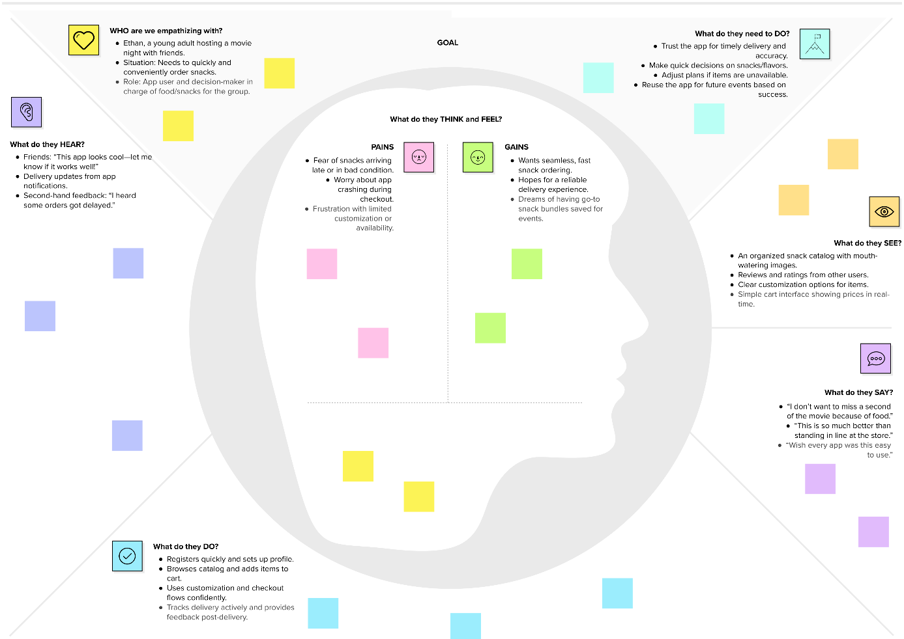

Reference: https://www.mural.co/templates/empathy-map-canvas

